**Subject :** Computer Networking

**Aim:** Implement Static Routing Algorithm

**Static Routing:**

Static routing is a type of network routing technique. Static routing is not a routing protocol; instead, it is the manual configuration and selection of a network route, usually managed by the network administrator. It is employed in scenarios where the network parameters and environment are expected to remain constant.   
  
Static routing is only optimal in a few situations. Network degradation, latency and congestion are inevitable consequences of the non-flexible nature of static routing because there is no adjustment when the primary route is unavailable.

Static routing performs routing decisions with preconfigured routes in the routing table, which can be changed manually only by administrators. Static routes are normally implemented in those situations where the choices in route selection are limited, or there is only a single default route available. Also, static routing can be used if you have only few devices for route configuration and there is no need for route change in the future.

**Implement Static Routing in Cisco Packet Tracer**

1. Create a Network in Cisco Packet Tracer

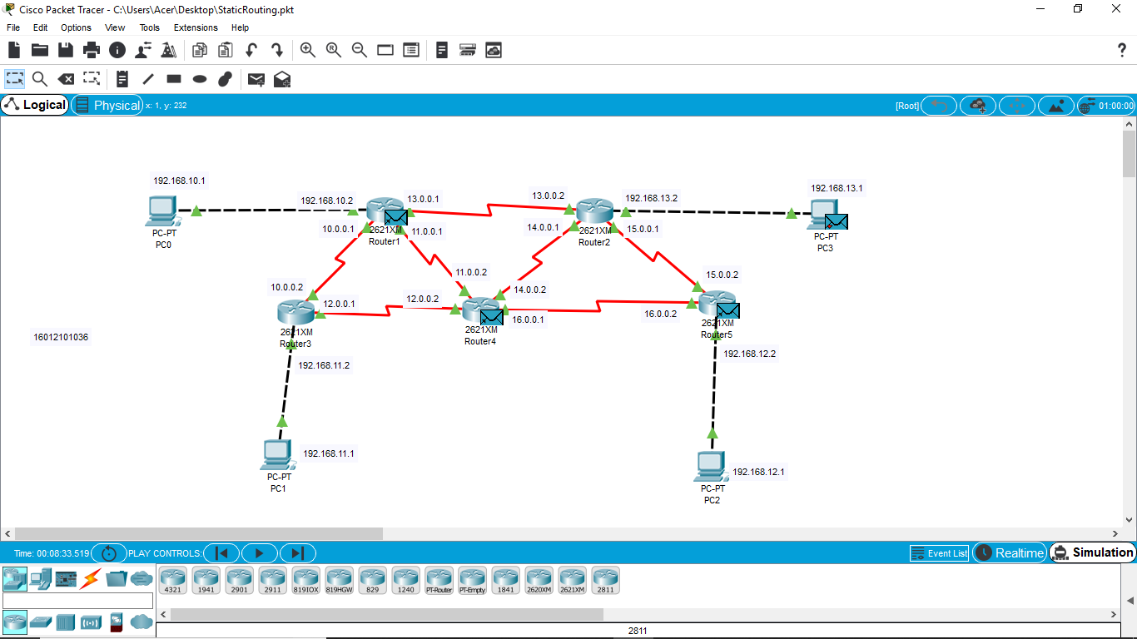

1. Give IP configuration to all Hosts

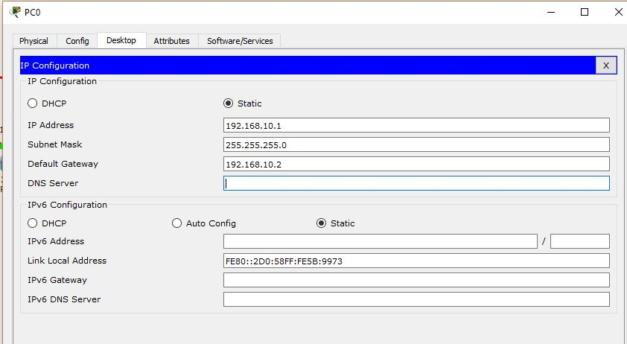

1. Give IP Configuration to all interfaces of all routers

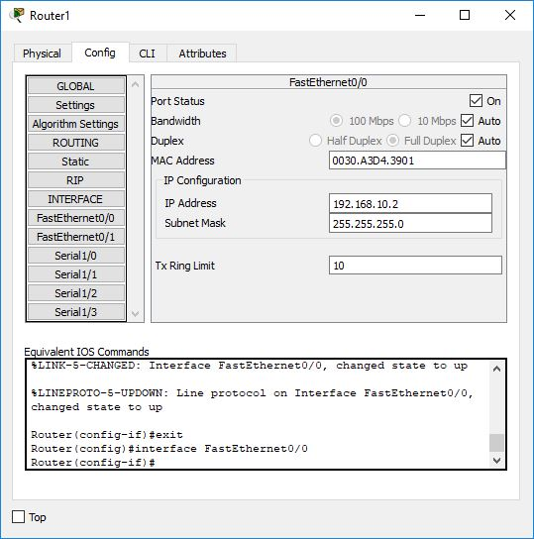

1. Make an entry in routing table in each router CLI for routing.
   1. Ip route <destination Network ID> <Destination SubnetMask> <First Interface>

Router-1

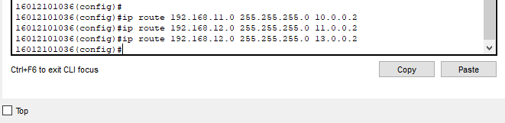

Router-2



Router-3



Router-4

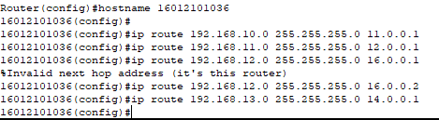

1. Send the message and test it.

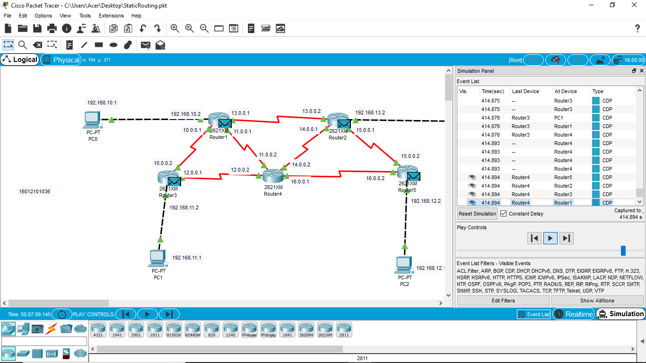

-------------------------------END -------------------------------------